Project: EHR SOFA — prediction of mortality among ventilated

Excluded patients who were on ventilator at admission

October 27, 2021

## Conditional Tree

### SOFA + all components

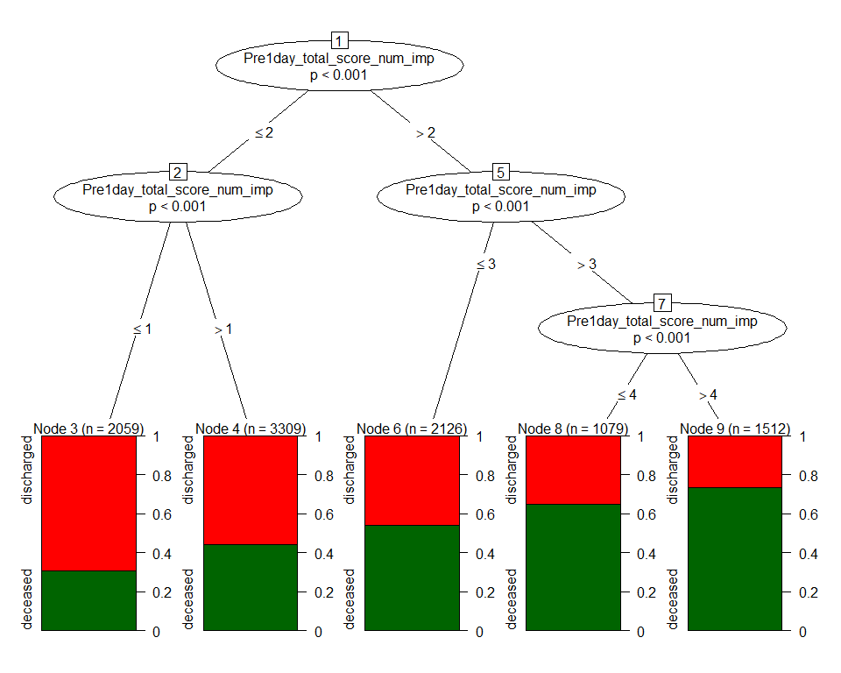

|  |  |  |
| --- | --- | --- |
| Variable | AUC.train | AUC.test |
| SOFA + all components | 0.656 (0.646,0.666) | 0.656 (0.641,0.67) |

### SOFA alone



|  |  |  |
| --- | --- | --- |
| Variable | AUC.train | AUC.test |
| SOFA | 0.656 (0.646,0.666) | 0.656 (0.641,0.67) |

### Categorical SOFA alone

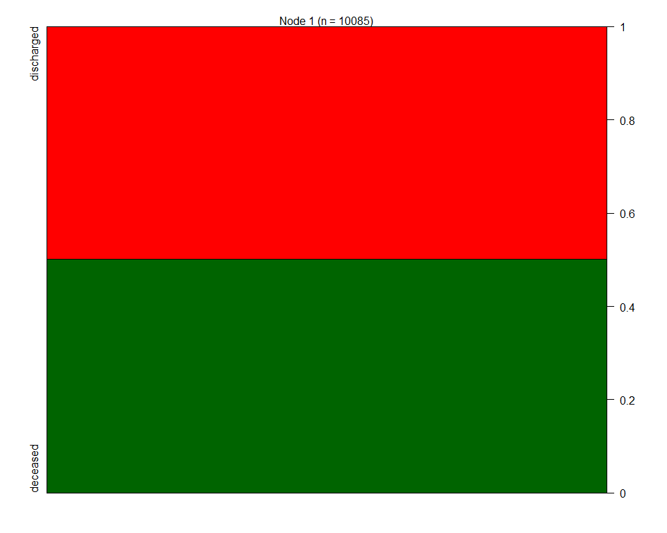

|  |  |  |
| --- | --- | --- |
| Variable | AUC.train | AUC.test |
| SOFA categories | 0.5 (0.5,0.5) | 0.5 (0.5,0.5) |

### Pulmonary sofa alone

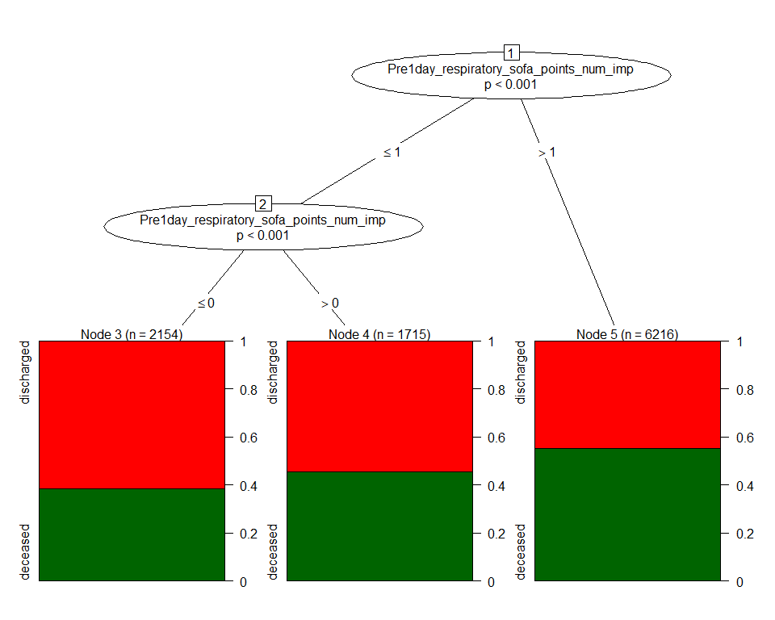

|  |  |  |
| --- | --- | --- |
| Variable | AUC.train | AUC.test |
| Pulmonary | 0.571 (0.561,0.58) | 0.58 (0.566,0.593) |

### Renal sofa alone



|  |  |  |
| --- | --- | --- |
| Variable | AUC.train | AUC.test |
| Renal | 0.5 (0.5,0.5) | 0.5 (0.5,0.5) |

### Heme sofa alone

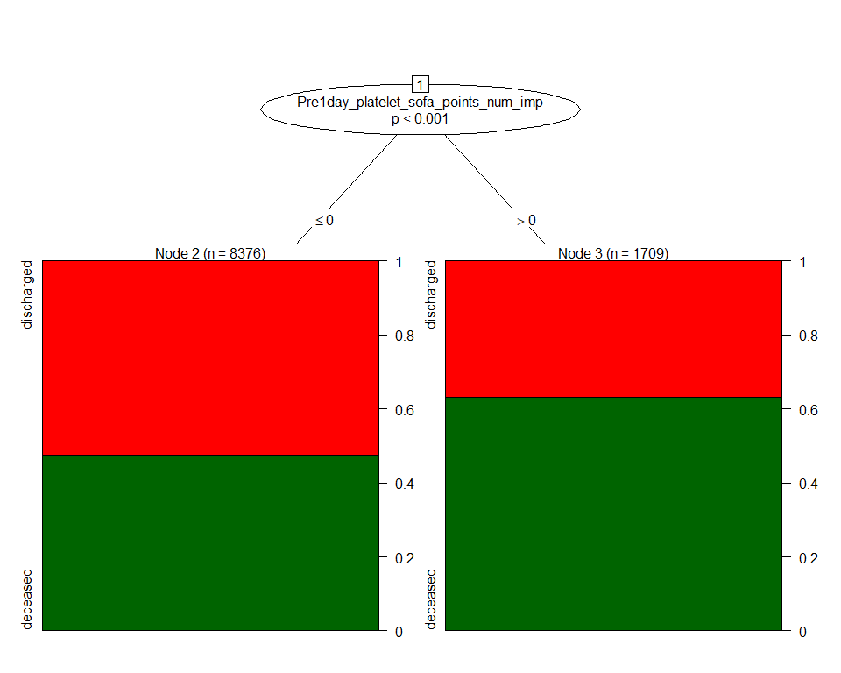

|  |  |  |
| --- | --- | --- |
| Variable | AUC.train | AUC.test |
| Heme | 0.544 (0.537,0.552) | 0.535 (0.524,0.545) |

### Neuro sofa alone

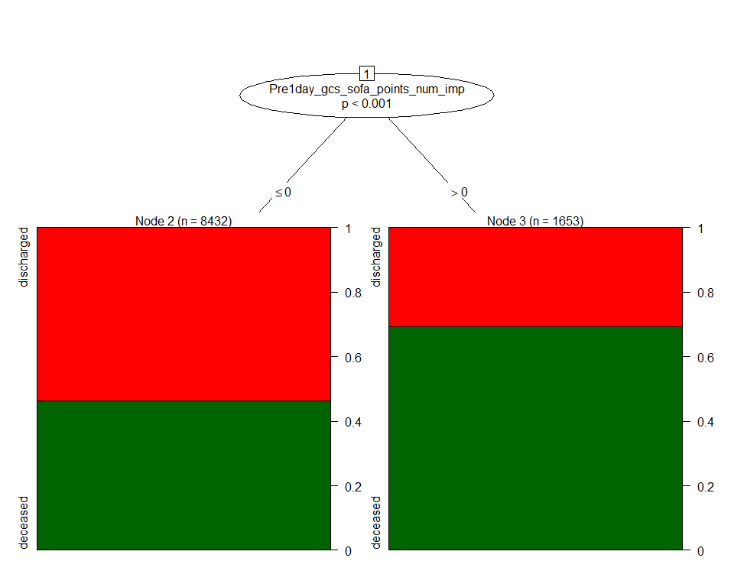

|  |  |  |
| --- | --- | --- |
| Variable | AUC.train | AUC.test |
| Neuro | 0.563 (0.555,0.57) | 0.565 (0.555,0.575) |

### Liver sofa alone

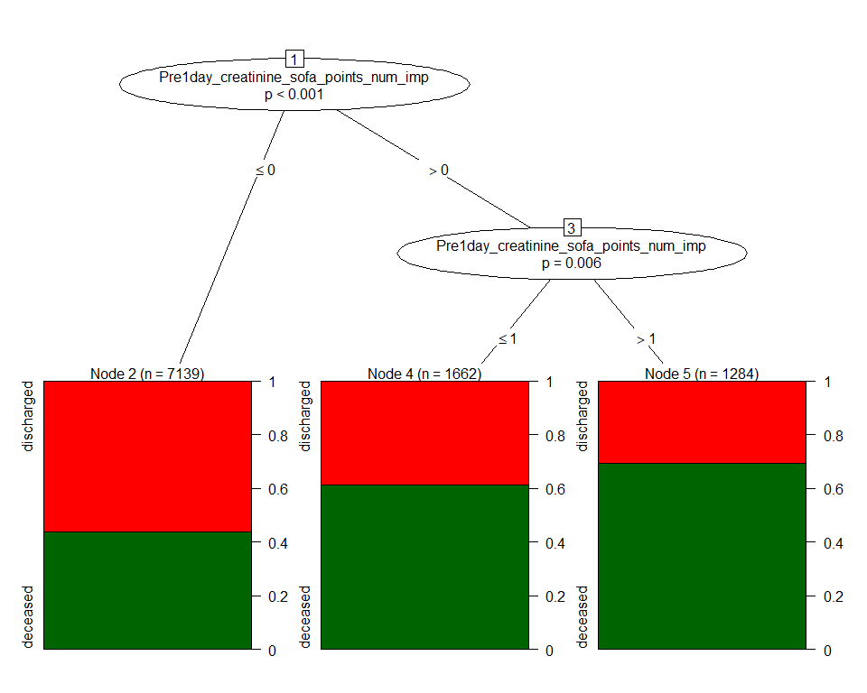

|  |  |  |
| --- | --- | --- |
| Variable | AUC.train | AUC.test |
| Liver | 0.59 (0.581,0.599) | 0.585 (0.572,0.598) |

### Cardio sofa alone

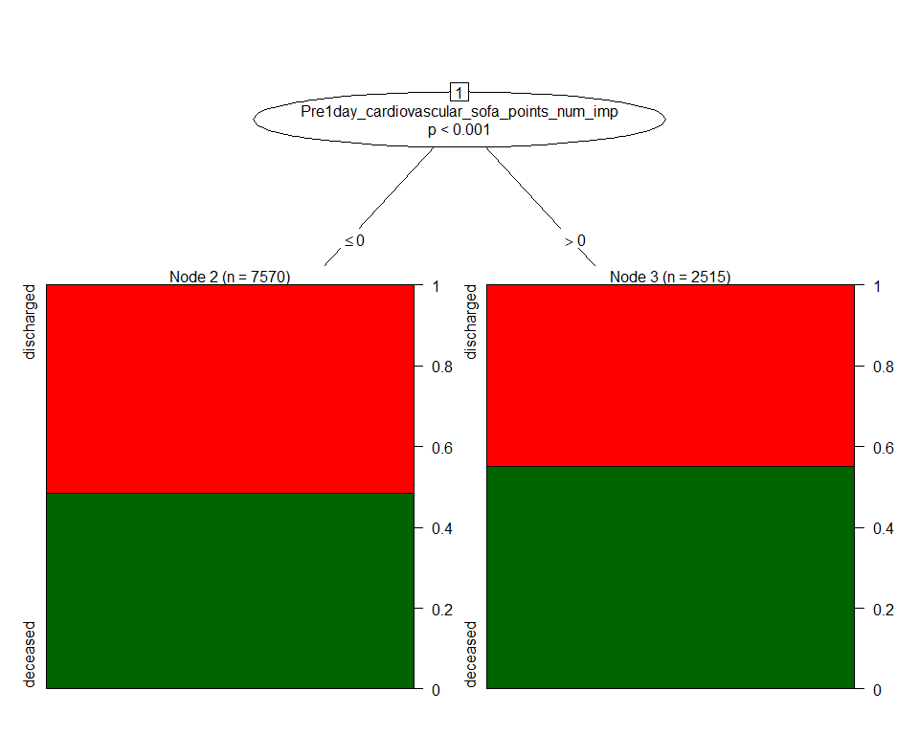

|  |  |  |
| --- | --- | --- |
| Variable | AUC.train | AUC.test |
| Cardio | 0.524 (0.516,0.533) | 0.522 (0.51,0.534) |

### SOFA + all components + age + gender + obesity +diabetes + hypertension

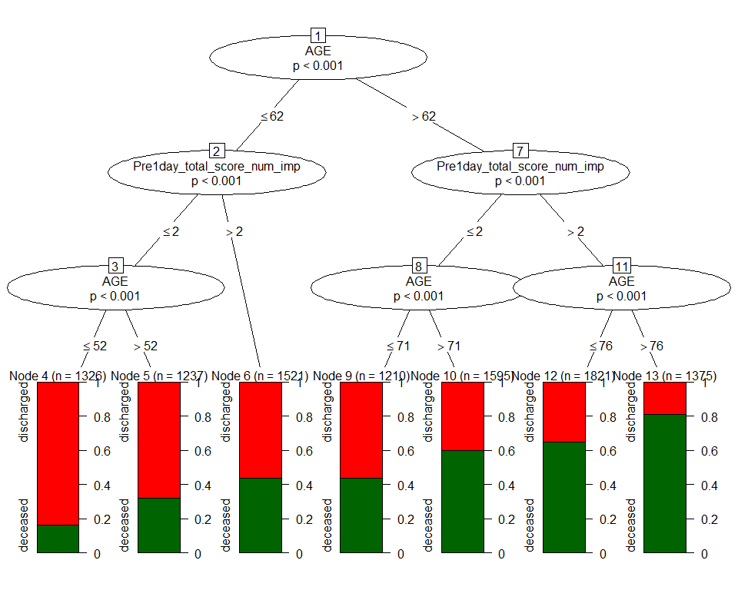

|  |  |  |
| --- | --- | --- |
| Variable | AUC.train | AUC.test |
| SOFA & all components + covariates | 0.719 (0.71,0.729) | 0.713 (0.699,0.727) |

### SOFA + age + gender + obesity +diabetes + hypertension



|  |  |  |
| --- | --- | --- |
| Variable | AUC.train | AUC.test |
| SOFA + covariates | 0.719 (0.71,0.729) | 0.713 (0.699,0.727) |

### Pulmonary sofa + age + gender + obesity +diabetes + hypertension

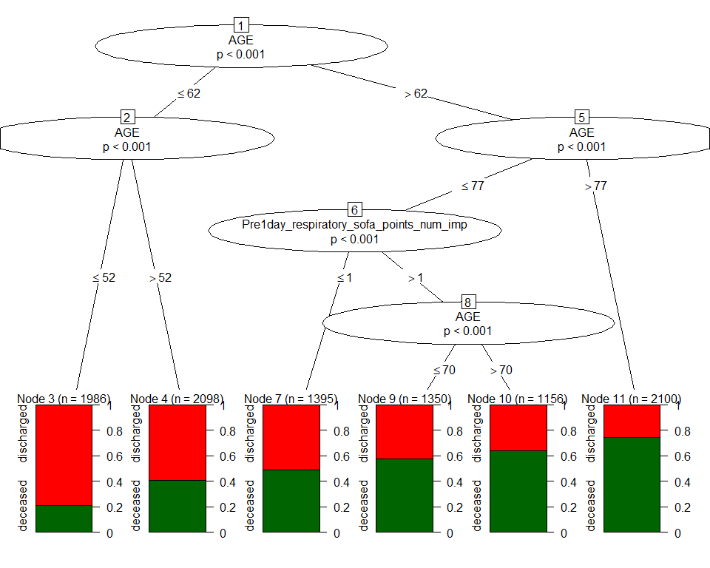

|  |  |  |
| --- | --- | --- |
| Variable | AUC.train | AUC.test |
| Pulmonary sofa + covariates | 0.706 (0.697,0.716) | 0.701 (0.687,0.715) |

### Renal sofa + age + gender + obesity +diabetes + hypertension

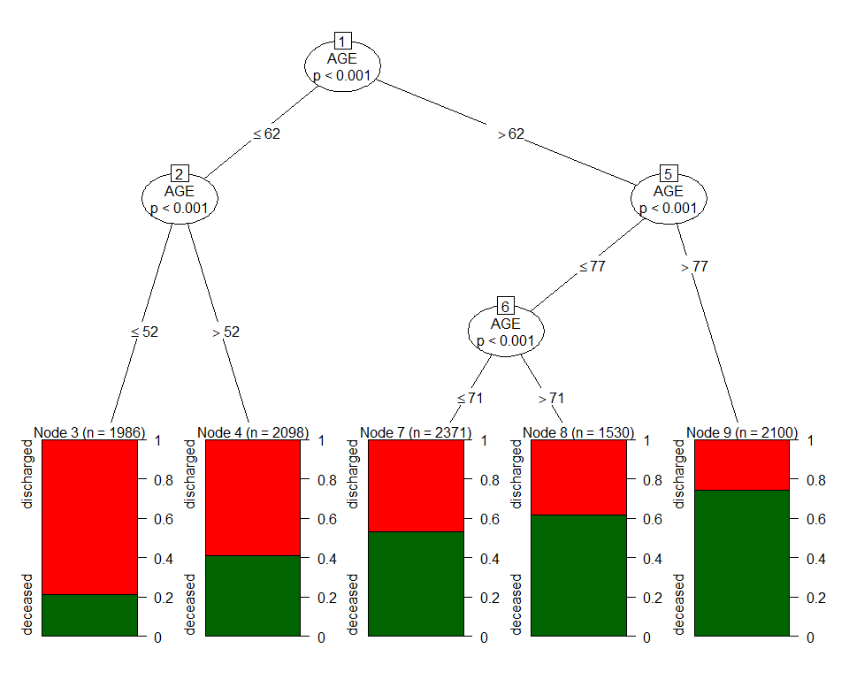

|  |  |  |
| --- | --- | --- |
| Variable | AUC.train | AUC.test |
| Renal sofa + covariates | 0.703 (0.693,0.713) | 0.696 (0.682,0.71) |

### Heme sofa + age + gender + obesity +diabetes + hypertension



|  |  |  |
| --- | --- | --- |
| Variable | AUC.train | AUC.test |
| Heme sofa + covariates | 0.703 (0.693,0.713) | 0.696 (0.682,0.71) |

### Neuro sofa + age + gender + obesity +diabetes + hypertension



|  |  |  |
| --- | --- | --- |
| Variable | AUC.train | AUC.test |
| Neuro sofa + covariates | 0.703 (0.693,0.713) | 0.696 (0.682,0.71) |

### Liver sofa + age + gender + obesity +diabetes + hypertension

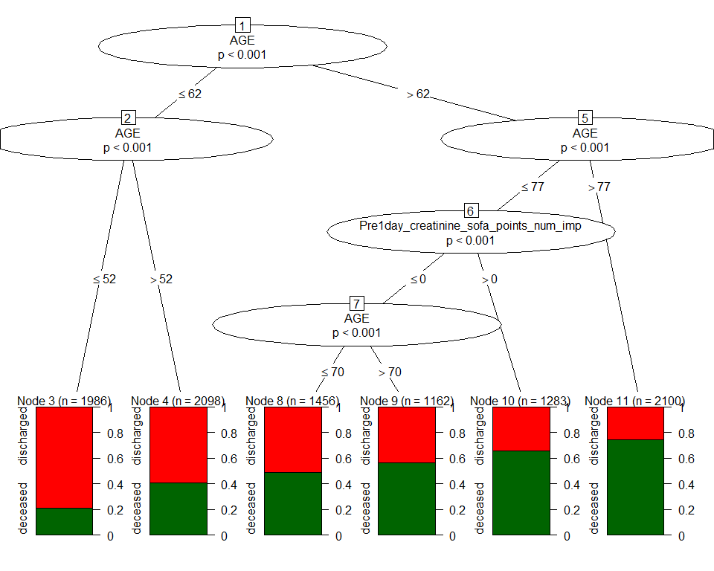

|  |  |  |
| --- | --- | --- |
| Variable | AUC.train | AUC.test |
| Liver sofa + covariates | 0.708 (0.698,0.718) | 0.702 (0.688,0.716) |

### Cardio sofa + age + gender + obesity +diabetes + hypertension



|  |  |  |
| --- | --- | --- |
| Variable | AUC.train | AUC.test |
| Cardio sofa + covariates | 0.703 (0.693,0.713) | 0.696 (0.682,0.71) |

### age



|  |  |  |
| --- | --- | --- |
| Variable | AUC.train | AUC.test |
| age | 0.703 (0.693,0.713) | 0.696 (0.682,0.71) |

### age + SOFA



|  |  |  |
| --- | --- | --- |
| Variable | AUC.train | AUC.test |
| age + SOFA | 0.719 (0.71,0.729) | 0.713 (0.699,0.727) |

### age + Categorical SOFA



|  |  |  |
| --- | --- | --- |
| Variable | AUC.train | AUC.test |
| age + Categorical SOFA | 0.703 (0.693,0.713) | 0.696 (0.682,0.71) |

### age + elixhauser score



|  |  |  |
| --- | --- | --- |
| Variable | AUC.train | AUC.test |
| age + elixhauser score | 0.703 (0.693,0.713) | 0.696 (0.682,0.71) |

### age + gender + obesity +diabetes + hypertension



|  |  |  |
| --- | --- | --- |
| Variable | AUC.train | AUC.test |
| covariates | 0.703 (0.693,0.713) | 0.696 (0.682,0.71) |

### SOFA + elixhauser score



|  |  |  |
| --- | --- | --- |
| Variable | AUC.train | AUC.test |
| SOFA + elixhauser score | 0.656 (0.646,0.666) | 0.656 (0.641,0.67) |

### Categories SOFA + elixhauser score

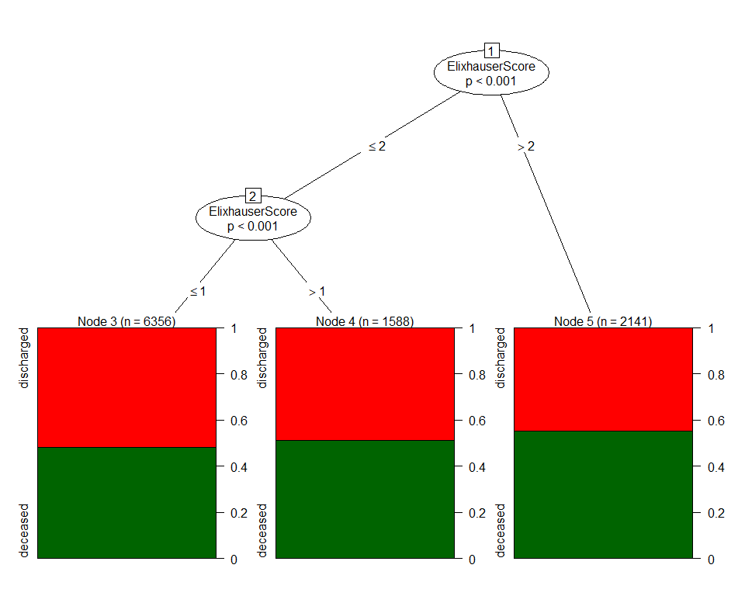

|  |  |  |
| --- | --- | --- |
| Variable | AUC.train | AUC.test |
| Categories SOFA + elixhauser score | 0.527 (0.518,0.537) | 0.524 (0.51,0.538) |

### SOFA + age + elixhauser score



|  |  |  |
| --- | --- | --- |
| Variable | AUC.train | AUC.test |
| SOFA + age + elixhauser score | 0.719 (0.71,0.729) | 0.713 (0.699,0.727) |

### SOFA + all components + age + elixhauser score



|  |  |  |
| --- | --- | --- |
| Variable | AUC.train | AUC.test |
| SOFA + all components + age + elixhauser score | 0.719 (0.71,0.729) | 0.713 (0.699,0.727) |

### Pulmonary sofa + age + elixhauser score



|  |  |  |
| --- | --- | --- |
| Variable | AUC.train | AUC.test |
| Pulmonary sofa + age + elixhauser score | 0.706 (0.697,0.716) | 0.701 (0.687,0.715) |

### Renal sofa + age + elixhauser score



|  |  |  |
| --- | --- | --- |
| Variable | AUC.train | AUC.test |
| Renal sofa + age + elixhauser score | 0.703 (0.693,0.713) | 0.696 (0.682,0.71) |

### Heme sofa + age + elixhauser score



|  |  |  |
| --- | --- | --- |
| Variable | AUC.train | AUC.test |
| Heme sofa + age + elixhauser score | 0.703 (0.693,0.713) | 0.696 (0.682,0.71) |

### Neuro sofa + age + elixhauser score



|  |  |  |
| --- | --- | --- |
| Variable | AUC.train | AUC.test |
| Neuro sofa + age + elixhauser score | 0.703 (0.693,0.713) | 0.696 (0.682,0.71) |

### Liver sofa + age + elixhauser score



|  |  |  |
| --- | --- | --- |
| Variable | AUC.train | AUC.test |
| Liver sofa + age + elixhauser score | 0.708 (0.698,0.718) | 0.702 (0.688,0.716) |

### Cardio sofa + age + elixhauser score



|  |  |  |
| --- | --- | --- |
| Variable | AUC.train | AUC.test |
| Cardio sofa + age + elixhauser score | 0.703 (0.693,0.713) | 0.696 (0.682,0.71) |

## GLM model

### SOFA alone

|  |  |  |  |  |
| --- | --- | --- | --- | --- |
| Variable | AUC.train | AUC.test | term | OR |
| SOFA | 0.66 (0.65,0.67) | 0.66 (0.64,0.67) | Pre1day_total_score_num_imp | 1.39 (1.35, 1.42) |

### Categorical SOFA alone

|  |  |  |  |  |
| --- | --- | --- | --- | --- |
| Variable | AUC.train | AUC.test | term | OR |
| Categorical SOFA | 0.55 (0.54,0.55) | 0.54 (0.54,0.55) | FourGrp_Pre1day_total_score_num_imp6 >= sofa <9 | 3.42 (2.89, 4.06) |
| Categorical SOFA | 0.55 (0.54,0.55) | 0.54 (0.54,0.55) | FourGrp_Pre1day_total_score_num_imp9 >= sofa <12 | 4.73 (3, 7.82) |
| Categorical SOFA | 0.55 (0.54,0.55) | 0.54 (0.54,0.55) | FourGrp_Pre1day_total_score_num_impsofa >= 12 | 5.89 (1.96, 25.32) |

### Pulmonary +Renal + Heme + Neuro + Liver + Cardio

|  |  |  |  |  |
| --- | --- | --- | --- | --- |
| Variable | AUC.train | AUC.test | term | OR |
| All SOFA components | 0.67 (0.66,0.68) | 0.67 (0.65,0.68) | Pre1day_bilirubin_sofa_points_num_imp | 1.47 (1.3, 1.67) |
| All SOFA components | 0.67 (0.66,0.68) | 0.67 (0.65,0.68) | Pre1day_creatinine_sofa_points_num_imp | 1.39 (1.33, 1.45) |
| All SOFA components | 0.67 (0.66,0.68) | 0.67 (0.65,0.68) | Pre1day_platelet_sofa_points_num_imp | 1.45 (1.34, 1.58) |
| All SOFA components | 0.67 (0.66,0.68) | 0.67 (0.65,0.68) | Pre1day_gcs_sofa_points_num_imp | 1.65 (1.53, 1.79) |
| All SOFA components | 0.67 (0.66,0.68) | 0.67 (0.65,0.68) | Pre1day_cardiovascular_sofa_points_num_imp | 1 (0.93, 1.08) |
| All SOFA components | 0.67 (0.66,0.68) | 0.67 (0.65,0.68) | Pre1day_respiratory_sofa_points_num_imp | 1.52 (1.44, 1.6) |

### SOFA + age + gender + obesity +diabetes + hypertension

|  |  |  |  |  |
| --- | --- | --- | --- | --- |
| Variable | AUC.train | AUC.test | term | OR |
| SOFA + covariates | 0.75 (0.74,0.76) | 0.74 (0.73,0.76) | Pre1day_total_score_num_imp | 1.33 (1.29, 1.36) |
| SOFA + covariates | 0.75 (0.74,0.76) | 0.74 (0.73,0.76) | AGE | 1.06 (1.05, 1.06) |
| SOFA + covariates | 0.75 (0.74,0.76) | 0.74 (0.73,0.76) | GENDERMale | 1.15 (1.05, 1.25) |
| SOFA + covariates | 0.75 (0.74,0.76) | 0.74 (0.73,0.76) | GENDERUnknown | 1.38 (0.68, 2.86) |
| SOFA + covariates | 0.75 (0.74,0.76) | 0.74 (0.73,0.76) | Obesity | 0.92 (0.79, 1.08) |
| SOFA + covariates | 0.75 (0.74,0.76) | 0.74 (0.73,0.76) | Diabetes | 1.18 (1.05, 1.32) |
| SOFA + covariates | 0.75 (0.74,0.76) | 0.74 (0.73,0.76) | Hyptertension | 0.84 (0.75, 0.93) |

### Pulmonary +Renal + Heme + Neuro + Liver + Cardio + age + gender + obesity +diabetes + hypertension

|  |  |  |  |  |
| --- | --- | --- | --- | --- |
| Variable | AUC.train | AUC.test | term | OR |
| All SOFA components + covariates | 0.75 (0.74,0.76) | 0.75 (0.73,0.76) | Pre1day_bilirubin_sofa_points_num_imp | 1.61 (1.42, 1.83) |
| All SOFA components + covariates | 0.75 (0.74,0.76) | 0.75 (0.73,0.76) | Pre1day_creatinine_sofa_points_num_imp | 1.32 (1.26, 1.38) |
| All SOFA components + covariates | 0.75 (0.74,0.76) | 0.75 (0.73,0.76) | Pre1day_platelet_sofa_points_num_imp | 1.38 (1.27, 1.51) |
| All SOFA components + covariates | 0.75 (0.74,0.76) | 0.75 (0.73,0.76) | Pre1day_gcs_sofa_points_num_imp | 1.34 (1.24, 1.46) |
| All SOFA components + covariates | 0.75 (0.74,0.76) | 0.75 (0.73,0.76) | Pre1day_cardiovascular_sofa_points_num_imp | 1.03 (0.95, 1.12) |
| All SOFA components + covariates | 0.75 (0.74,0.76) | 0.75 (0.73,0.76) | Pre1day_respiratory_sofa_points_num_imp | 1.49 (1.41, 1.58) |
| All SOFA components + covariates | 0.75 (0.74,0.76) | 0.75 (0.73,0.76) | AGE | 1.06 (1.05, 1.06) |
| All SOFA components + covariates | 0.75 (0.74,0.76) | 0.75 (0.73,0.76) | GENDERMale | 1.12 (1.03, 1.23) |
| All SOFA components + covariates | 0.75 (0.74,0.76) | 0.75 (0.73,0.76) | GENDERUnknown | 1.42 (0.7, 2.94) |
| All SOFA components + covariates | 0.75 (0.74,0.76) | 0.75 (0.73,0.76) | Obesity | 0.92 (0.79, 1.08) |
| All SOFA components + covariates | 0.75 (0.74,0.76) | 0.75 (0.73,0.76) | Diabetes | 1.19 (1.06, 1.33) |
| All SOFA components + covariates | 0.75 (0.74,0.76) | 0.75 (0.73,0.76) | Hyptertension | 0.83 (0.74, 0.93) |

### SOFA + age + elixhauser score

|  |  |  |  |  |
| --- | --- | --- | --- | --- |
| Variable | AUC.train | AUC.test | term | OR |
| SOFA + age + elixhauser score | 0.75 (0.74,0.76) | 0.74 (0.73,0.76) | Pre1day_total_score_num_imp | 1.33 (1.3, 1.36) |
| SOFA + age + elixhauser score | 0.75 (0.74,0.76) | 0.74 (0.73,0.76) | AGE | 1.06 (1.05, 1.06) |
| SOFA + age + elixhauser score | 0.75 (0.74,0.76) | 0.74 (0.73,0.76) | ElixhauserScore | 1 (0.97, 1.03) |

### Pulmonary +Renal + Heme + Neuro + Liver + Cardio + age + elixhauser score

|  |  |  |  |  |
| --- | --- | --- | --- | --- |
| Variable | AUC.train | AUC.test | term | OR |
| SOFA components + age + elixhauser score | 0.75 (0.74,0.76) | 0.74 (0.73,0.76) | Pre1day_bilirubin_sofa_points_num_imp | 1.62 (1.43, 1.84) |
| SOFA components + age + elixhauser score | 0.75 (0.74,0.76) | 0.74 (0.73,0.76) | Pre1day_creatinine_sofa_points_num_imp | 1.32 (1.26, 1.39) |
| SOFA components + age + elixhauser score | 0.75 (0.74,0.76) | 0.74 (0.73,0.76) | Pre1day_platelet_sofa_points_num_imp | 1.39 (1.27, 1.51) |
| SOFA components + age + elixhauser score | 0.75 (0.74,0.76) | 0.74 (0.73,0.76) | Pre1day_gcs_sofa_points_num_imp | 1.35 (1.24, 1.46) |
| SOFA components + age + elixhauser score | 0.75 (0.74,0.76) | 0.74 (0.73,0.76) | Pre1day_cardiovascular_sofa_points_num_imp | 1.03 (0.95, 1.11) |
| SOFA components + age + elixhauser score | 0.75 (0.74,0.76) | 0.74 (0.73,0.76) | Pre1day_respiratory_sofa_points_num_imp | 1.49 (1.41, 1.58) |
| SOFA components + age + elixhauser score | 0.75 (0.74,0.76) | 0.74 (0.73,0.76) | AGE | 1.06 (1.05, 1.06) |
| SOFA components + age + elixhauser score | 0.75 (0.74,0.76) | 0.74 (0.73,0.76) | ElixhauserScore | 1 (0.98, 1.03) |

### age

|  |  |  |  |  |
| --- | --- | --- | --- | --- |
| Variable | AUC.train | AUC.test | term | OR |
| age | 0.71 (0.7,0.72) | 0.71 (0.69,0.72) | AGE | 1.06 (1.06, 1.06) |

### age + SOFA

|  |  |  |  |  |
| --- | --- | --- | --- | --- |
| Variable | AUC.train | AUC.test | term | OR |
| age + SOFA | 0.75 (0.74,0.76) | 0.74 (0.73,0.76) | AGE | 1.06 (1.05, 1.06) |
| age + SOFA | 0.75 (0.74,0.76) | 0.74 (0.73,0.76) | Pre1day_total_score_num_imp | 1.33 (1.3, 1.36) |

### age + Categories SOFA

|  |  |  |  |  |
| --- | --- | --- | --- | --- |
| Variable | AUC.train | AUC.test | term | OR |
| age + Categories SOFA | 0.73 (0.72,0.74) | 0.72 (0.71,0.73) | AGE | 1.06 (1.05, 1.06) |
| age + Categories SOFA | 0.73 (0.72,0.74) | 0.72 (0.71,0.73) | FourGrp_Pre1day_total_score_num_imp6 >= sofa <9 | 3.18 (2.67, 3.82) |
| age + Categories SOFA | 0.73 (0.72,0.74) | 0.72 (0.71,0.73) | FourGrp_Pre1day_total_score_num_imp9 >= sofa <12 | 4.92 (3.05, 8.3) |
| age + Categories SOFA | 0.73 (0.72,0.74) | 0.72 (0.71,0.73) | FourGrp_Pre1day_total_score_num_impsofa >= 12 | 6.66 (2.13, 29.31) |

### age + Elixhauser score

|  |  |  |  |  |
| --- | --- | --- | --- | --- |
| Variable | AUC.train | AUC.test | term | OR |
| age + Elixhauser score | 0.71 (0.7,0.72) | 0.71 (0.69,0.72) | AGE | 1.06 (1.05, 1.06) |
| age + Elixhauser score | 0.71 (0.7,0.72) | 0.71 (0.69,0.72) | ElixhauserScore | 1.03 (1.01, 1.06) |

### SOFA + Elixhauser score

|  |  |  |  |  |
| --- | --- | --- | --- | --- |
| Variable | AUC.train | AUC.test | term | OR |
| SOFA + Elixhauser score | 0.66 (0.65,0.67) | 0.66 (0.65,0.68) | Pre1day_total_score_num_imp | 1.38 (1.35, 1.42) |
| SOFA + Elixhauser score | 0.66 (0.65,0.67) | 0.66 (0.65,0.68) | ElixhauserScore | 1.04 (1.01, 1.07) |

### Categories SOFA + Elixhauser score

|  |  |  |  |  |
| --- | --- | --- | --- | --- |
| Variable | AUC.train | AUC.test | term | OR |
| Categories SOFA + Elixhauser score | 0.57 (0.56,0.58) | 0.56 (0.55,0.58) | FourGrp_Pre1day_total_score_num_imp6 >= sofa <9 | 3.33 (2.82, 3.96) |
| Categories SOFA + Elixhauser score | 0.57 (0.56,0.58) | 0.56 (0.55,0.58) | FourGrp_Pre1day_total_score_num_imp9 >= sofa <12 | 4.59 (2.91, 7.59) |
| Categories SOFA + Elixhauser score | 0.57 (0.56,0.58) | 0.56 (0.55,0.58) | FourGrp_Pre1day_total_score_num_impsofa >= 12 | 5.75 (1.91, 24.76) |
| Categories SOFA + Elixhauser score | 0.57 (0.56,0.58) | 0.56 (0.55,0.58) | ElixhauserScore | 1.06 (1.03, 1.09) |

## Calibration plot

Produced calibration plots for logistic regression models using Age, SOFA, SOFA categories, SOFA + Age, or SOFA + Covariates as the regressors.

## ROC plot

Generated ROC curves for continuous SOFA, categorized SOFA, Age alone and SOFA + Age

DeLong's test for two correlated ROC curves  
  
data: roc.train.sofa and roc.train.sofaCat  
Z = 23.825, p-value < 2.2e-16  
alternative hypothesis: true difference in AUC is not equal to 0  
sample estimates:  
AUC of roc1 AUC of roc2   
 65.79736 54.71948

DeLong's test for two correlated ROC curves  
  
data: roc.train.sofa and roc.train.sofaAge  
Z = -19.054, p-value < 2.2e-16  
alternative hypothesis: true difference in AUC is not equal to 0  
sample estimates:  
AUC of roc1 AUC of roc2   
 65.79736 74.66524

DeLong's test for two ROC curves  
  
data: roc.train.age and roc.train.sofaAge  
D = -5.1669, df = 20110, p-value = 2.403e-07  
alternative hypothesis: true difference in AUC is not equal to 0  
sample estimates:  
AUC of roc1 AUC of roc2   
 71.05217 74.66524

png   
 2

DeLong's test for two correlated ROC curves  
  
data: roc.test.sofa and roc.test.sofaCat  
Z = 17.678, p-value < 2.2e-16  
alternative hypothesis: true difference in AUC is not equal to 0  
sample estimates:  
AUC of roc1 AUC of roc2   
 65.90560 54.31848

DeLong's test for two correlated ROC curves  
  
data: roc.test.sofa and roc.test.sofaAge  
Z = -12.837, p-value < 2.2e-16  
alternative hypothesis: true difference in AUC is not equal to 0  
sample estimates:  
AUC of roc1 AUC of roc2   
 65.90560 74.20903

DeLong's test for two correlated ROC curves  
  
data: roc.test.age and roc.test.sofaAge  
Z = -8.0381, p-value = 9.121e-16  
alternative hypothesis: true difference in AUC is not equal to 0  
sample estimates:  
AUC of roc1 AUC of roc2   
 70.80156 74.20903

png   
 2